A medium-sized business is researching available options for connecting to the Internet. The company is looking for a high speed option with dedicated, symmetric access. Which connection type should the company choose?
Correct  Response | Your  Response
 | DSL
 | dialup
 | satellite
 | leased line
 | cable modem

This item references content from the following areas:
Introduction to Networks
- 1.2.4 Connecting to the Internet

4
  For which three reasons was a packet-switched connectionless data communications technology used when developing the Internet? (Choose three.)
  Correct  Response | Your  Response
   | It can rapidly adapt to the loss of data transmission facilities.
   | It efficiently utilizes the network infrastructure to transfer data.
   | Data packets can travel multiple paths through the network simultaneously.
   | It allows for billing of network use by the amount of time a connection is established.
   | It requires that a data circuit between the source and destination be established before data can be transferred.

This item references content from the following areas:
Introduction to Networks
- 1.3.2 Reliable Network

5
  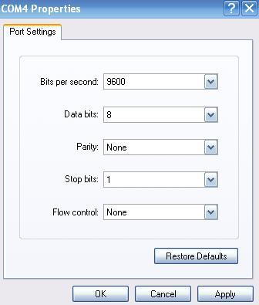Refer to the exhibit. A network engineer is attempting to connect to a new router to perform the initial configuration. The engineer connects a rollover cable from the serial port of a PC to the Aux port on the router, then configures HyperTerminal as shown. The engineer cannot get a login prompt in HyperTerminal. What would fix the problem?
  Correct  Response | Your  Response
   | Connect to the Ethernet port on the PC.
   | Change connection settings to even parity.
   | Move the cable to the router console port.
   | Use a crossover cable instead of a rollover cable.

This item references content from the following areas:
Introduction to Networks
- 2.1.2 Accessing a Cisco IOS Device

7
  A network administrator enters the service password-encryption command into the configuration mode of a router. What does this command accomplish?
  Correct  Response | Your  Response
   | This command encrypts passwords as they are transmitted across serial WAN links.
   | This command prevents someone from viewing the running configuration passwords.
   | This command enables a strong encryption algorithm for the enable secret password command.
   | This command automatically encrypts passwords in configuration files that are currently stored in NVRAM.
   | This command provides an exclusive encrypted password for external service personnel who are required to do router maintenance.

This item references content from the following areas:
Introduction to Networks
- 2.2.2 Limiting Access to Device Configurations

8
  A user is attempting to do an http://www.cisco.com/ without success. Which two configuration values must be set on the host to allow this access? (Choose two.)
  Correct  Response | Your  Response
   | DNS server
   | WINS server
   | HTTP server
   | default gateway
   | Netbios

This item references content from the following areas:
Introduction to Networks
- 3.3.3 Accessing Remote Resources
- 10.2.2 Providing IP addressing Services

9
  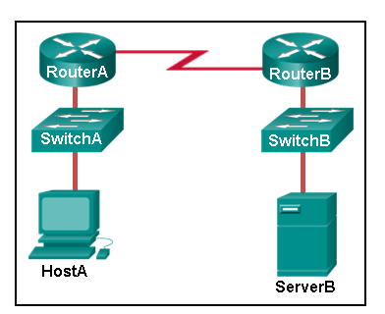Refer to the exhibit. HostA is attempting to contact ServerB. Which two statements correctly describe the addressing that HostA will generate in the process? (Choose two.)
  Correct  Response | Your  Response
   | A packet with the destination IP address of RouterB.
   | A frame with the destination MAC address of SwitchA.
   | A packet with the destination IP address of RouterA.
   | A frame with the destination MAC address of RouterA.
   | A packet with the destination IP address of ServerB.
   | A frame with the destination MAC address of ServerB.
  In order to send data to ServerB, HostA will generate a packet that contains the IP address of the destination device on the remote network and a frame that contains the MAC address of the default gateway device on the local network.

This item references content from the following areas:
Introduction to Networks
- 3.3.3 Accessing Remote Resources

10
  What three primary functions does data link layer encapsulation provide? (Choose three.)
  Correct  Response | Your  Response
   | addressing
   | error detection
   | frame delimiting
   | port identification
   | path determination
   | IP address resolution

This item references content from the following areas:
Introduction to Networks
- 4.1.1 Getting It Connected

12
  What makes fiber preferable to copper cabling for interconnecting buildings? (Choose three.)
  Correct  Response | Your  Response
   | greater distances per cable run
   | lower installation cost
   | limited susceptibility to EMI/RFI
   | durable connections
   | greater bandwidth potential
   | easily terminated

This item references content from the following areas:
Introduction to Networks
- 4.2.3 Fiber Optic Cabling

13
  A network team is comparing physical WAN topologies for connecting remote sites to a headquarters building. Which topology provides high availability and connects some, but not all, remote sites?
  Correct  Response | Your  Response
   | mesh
   | partial mesh
   | hub and spoke
   | point-to-point
  Partial mesh topologies provide high availability by interconnecting multiple remote sites, but do not require a connection between all remote sites. A mesh topology requires point-to-point links with every system being connected to every other system. A point-to-point topology is where each device is connected to one other device. A hub and spoke uses a central device in a star topology that connects to other point-to-point devices.

This item references content from the following areas:
Introduction to Networks
- 4.4.2 WAN Topologies

14
  What is the function of CSMA/CA in a WLAN?
  Correct  Response | Your  Response
   | It provides the mechanism for media access.
   | It describes the smallest building block of the WLAN.
   | It assures that clients are connected to the correct WLAN.
   | It allows a host to move between cells without loss of signal.

This item references content from the following areas:
Introduction to Networks
- 4.4.3 LAN Topologies

15
  What are two actions performed by a Cisco switch? (Choose two.)
  Correct  Response | Your  Response
   | building a routing table that is based on the first IP address in the frame header
   | using the source MAC addresses of frames to build and maintain a MAC address table
   | forwarding frames with unknown destination IP addresses to the default gateway
   | utilizing the MAC address table to forward frames via the destination MAC address
   | examining the destination MAC address to add new entries to the MAC address table

This item references content from the following areas:
Introduction to Networks
- 5.3.1 Switching

17
  Which two statements are correct in a comparison of IPv4 and IPv6 packet headers? (Choose two.)
  Correct  Response | Your  Response
   | The Header Checksum field name from IPv4 is kept in IPv6.
   | The Destination Address field is new in IPv6.
   | The Source Address field name from IPv4 is kept in IPv6.
   | The Version field from IPv4 is not kept in IPv6.
   | The Time-to-Live field from IPv4 has been replaced by the Hop Limit field in IPv6.
  The IPv6 packet header fields are as follows: Version, Traffic Class, Flow Label, Payload Length, Next Header, Hop Limit, Source Address, and Destination Address. The IPv4 packet header fields include the following: Version, Differentiated Services, Time-to-Live, Protocol, Source IP Address, and Destination IP Address. Both versions have a 4-bit Version field. Both versions have a Source (IP) Address field. IPv4 addresses are 32 bits; IPv6 addresses are 128 bits. The Time-to-Live or TTL field in IPv4 is now called Hop Limit in IPv6, but this field serves the same purpose in both versions. The value in this 8-bit field decrements each time a packet passes through any router. When this value is 0, the packet is discarded and is not forwarded to any other router.

This item references content from the following areas:
Introduction to Networks
- 6.1.3 IPv4 Packet
- 6.1.4 IPv6 Packet

18
  Which two functions are primary functions of a router? (Choose two.)
  Correct  Response | Your  Response
   | packet switching
   | microsegmentation
   | domain name resolution
   | path selection
   | flow control

This item references content from the following areas:
Introduction to Networks
- 6.2.2 Router Routing Tables

21
  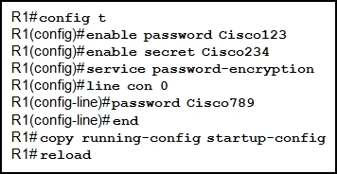Refer to the exhibit. What will be the result of entering this configuration the next time a network administrator connects a console cable to the router and no additional commands have been entered?
  Correct  Response | Your  Response
   | The administrator will be required to enter Cisco123.
   | The administrator will be required to enter Cisco234.
   | The administrator will be required to enter Cisco789.
   | The administrator will be presented with the R1> prompt.
  Until both the password password and the login commands are entered in console line configuration mode, no password is required to gain access to enable mode.

This item references content from the following areas:
Introduction to Networks
- 6.4.1 Configure Initial Settings

22
  Why are port numbers included in the TCP header of a segment?
  Correct  Response | Your  Response
   | to indicate the correct router interface that should be used to forward a segment
   | to identify which switch ports should receive or forward the segment
   | to determine which Layer 3 protocol should be used to encapsulate the data
   | to enable a receiving host to forward the data to the appropriate application
   | to allow the receiving host to assemble the packet in the proper order

This item references content from the following areas:
Introduction to Networks
- 7.1.2 Introducing TCP and UDP

23
  What is one purpose of the TCP three-way handshake?
  Correct  Response | Your  Response
   | sending echo requests from the source to the destination host to establish the presence of the destination
   | determining the IP address of the destination host in preparation for data transfer
   | requesting the destination to transfer a binary file to the source
   | synchronizing sequence numbers between source and destination in preparation for data transfer

This item references content from the following areas:
Introduction to Networks
- 7.2.1 TCP Communication

24
  What are two ways that TCP uses the sequence numbers in a segment? (Choose two.)
  Correct  Response | Your  Response
   | to identify missing segments at the destination
   | to reassemble the segments at the remote location
   | to specify the order in which the segments travel from source to destination
   | to limit the number of segments that can be sent out of an interface at one time
   | to determine if the packet changed during transit

This item references content from the following areas:
Introduction to Networks
- 7.2.2 Reliability and Flow Control

25
  A PC that is communicating with a web server is utilizing a window size of 6,000 bytes when sending data and a packet size of 1,500 bytes. What byte of information will the web server acknowledge after it has received four packets of data from the PC?
  Correct  Response | Your  Response
   | 5
   | 1,500
   | 1,501
   | 6,000
   | 6,001

This item references content from the following areas:
Introduction to Networks
- 7.2.2 Reliability and Flow Control

26
  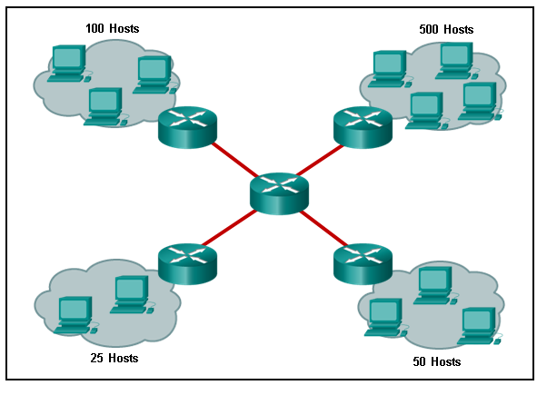Refer to the exhibit. Using VLSM, what is the largest and smallest subnet mask required on this network in order to minimize address waste?
  Correct  Response | Your  Response
   | 255.255.254.0 and 255.255.255.224
   | 255.255.254.0 and 255.255.255.252
   | 255.255.255.128 and 255.255.255.224
   | 255.255.255.0 and 255.255.255.252
  The largest subnet requires 500 hosts addresses, so the most efficient subnet would be a /23 with the mask 255.255.254.0. The smallest subnet, the links between the routers, requires two addresses each, so a /30 subnet with the mask 255.255.255.252 is required.

This item references content from the following areas:
Introduction to Networks
- 9.1.5 Benefits of Variable Length Subnet Masking

27
  A network administrator has been issued a network address of 192.31.7.64/26. How many subnets of equal size could be created from the assigned /26 network by using a /28 prefix?
  Correct  Response | Your  Response
   | 3
   | 4
   | 6
   | 8
   | 14
   | 16
  A /26 prefix requires the first 2 bits of the last octet for the network portion. The last octet of the assigned network address (64) is 0100 0000 with the first 2 bits reserved for the network portion. Our beginning values go from 192.31.7.64 through to 192.31.7.127. If we now further subdivide that range using a /28 prefix, we need to borrow 2 more bits. Remember that to remain within the .64 to .127 range, the first two bits MUST remain as 01. Because we have only 2 more bits to work with, there are only 4 different combinations.
  192.31.7.64 - 0100 0000
  192.31.7.80 - 0101 0000
  192.31.7.96 - 0110 00000
  192.31.7.112 - 0111 00000 Notice that the subnets increment by 16.

This item references content from the following areas:
Introduction to Networks
- 9.1.5 Benefits of Variable Length Subnet Masking

30
  Which IPv6 address notation is valid?
  Correct  Response | Your  Response
   | 2001:0DB8::ABCD::1234
   | ABCD:160D::4GAB:FFAB
   | 2001:DB8:0:1111::200
   | 2001::ABCD::
  IPv6 addresses are represented by 32 hexadecimal digits (0-9, A-F). The size of the notation can be reduced by eliminating leading zeroes in any hextet and by replacing a single, contiguous string of hextets containing all zeroes with a double colon, which can only be used one time.

This item references content from the following areas:
Introduction to Networks
- 8.2.2 IPv6 Addressing

32
  The administrator of a branch office receives an IPv6 prefix of 2001:db8:3000::/52 from the corporate network manager. How many subnets can the administrator create?
  Correct  Response | Your  Response
   | 1024
   | 2048
   | 4096
   | 8192
   | 65536
  The last 64 bits of an IPv6 address are used as the Interface ID. Subnetting a /52 prefix without going beyond the 64 bits allocated by default for the interface ID allows 12 bits for creating subnets. Thus, there will be 2¹² or 4096 subnets.

This item references content from the following areas:
Introduction to Networks
- 9.3.1 Subnetting an IPv6 Network

34
  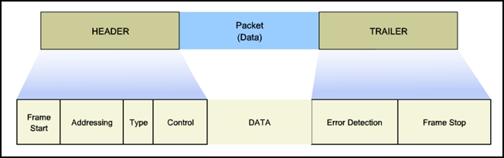Refer to the exhibit. Which layer of the OSI model would format data in this way?
  Correct  Response | Your  Response
   | physical
   | network
   | data link
   | transport
   | application
  The data link layer PDU is referred to as a frame, which can also be seen in both the header and trailer in the exhibit. Ethernet adds both a header and a trailer to the data as it is passed down from Layer 3.

This item references content from the following areas:
Introduction to Networks
- 4.3.2 Layer 2 Frame Structure

35
  What three statements describe features or functions of media access control? (Choose three.)
  Correct  Response | Your  Response
   | Controlled media access involves collision handling.
   | It is responsible for detecting transmission errors in transmitted data.
   | It uses contention-based access also known as deterministic access.
   | 802.11 utilizes CSMA/CD.
   | Data link layer protocols define the rules for access to different media.
   | Ethernet utilizes CSMA/CD.
  Layer 2 of the OSI model is responsible for accessing and placing the data on the media. It executes CRC calculations on parts of the encapsulated data to verify the integrity of the transmitted data. Media access methods have two major categories: non-deterministic contention based or deterministic controlled access. 802.11 is a wireless standard that uses CSMA/CA.

This item references content from the following areas:
Introduction to Networks
- 4.4.3 LAN Topologies

38
  What will a host on an Ethernet network do if it receives a frame with a destination MAC address that does not match its own MAC address?
  Correct  Response | Your  Response
   | It will discard the frame.
   | It will forward the frame to the next host.
   | It will remove the frame from the media.
   | It will strip off the data-link frame to check the destination IP address.
  In an Ethernet network, each NIC in the network checks every arriving frame to see if the destination MAC address in the frame matches its own MAC address. If there is no match, the device discards the frame. If there is a match, the NIC passes the frame up to the next OSI layer.

This item references content from the following areas:
Introduction to Networks
- 5.1.1 Ethernet Operation

40
  Which two types of applications rely on their traffic having priority over other traffic types through the network? (Choose two.)
  Correct  Response | Your  Response
   | email
   | file transfer
   | instant messaging
   | video
   | voice
  Real-time applications, such as voice and video, rely on optimized treatment compared to other traffic on the network in order to provide reliable service.

This item references content from the following areas:
Introduction to Networks
- 11.1.2 Protocols in a Small Network

42
  Which router configuration mode would an administrator use to configure the router for SSH or Telnet login access?
  Correct  Response | Your  Response
   | line
   | router
   | global
   | interface
   | privileged EXEC

This item references content from the following areas:
Introduction to Networks
- 11.2.4 Securing Devices

43
  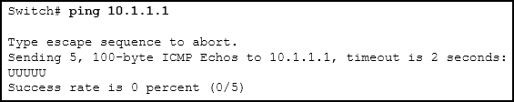Refer to the exhibit. An administrator is testing connectivity to a remote device with the IP address 10.1.1.1. What does the output of this command indicate?
  Correct  Response | Your  Response
   | Connectivity to the remote device was successful.
   | A router along the path did not have a route to the destination.
   | A ping packet is being blocked by a security device along the path.
   | The connection timed out while waiting for a reply from the remote device.
  In the output of the ping command, an exclamation mark (!) indicates a response was successfully received, a period (.) indicates that the connection timed out while waiting for a reply, and the letter "U" indicates that a router along the path did not have a route to the destination and sent an ICMP destination unreachable message back to the source.

This item references content from the following areas:
Introduction to Networks
- 2.3.3 Verifying Connectivity
- 11.3.1 Ping

44
  Which is a function of the show ip route command when used as a tool for troubleshooting network connectivity?
  Correct  Response | Your  Response
   | indicates the point of failure in the connection
   | shows the IP address of the next hop router for each route
   | lists the IP addresses of all hops the traffic will pass through to reach the destination network
   | shows the incoming and outgoing interfaces the traffic will go through in order to reach the destination network

This item references content from the following areas:
Introduction to Networks
- 11.3.3 Show Commands

46
  To revert to a previous configuration, an administrator issues the command copy tftp startup-config on a router and enters the host address and file name when prompted. After the command is completed, why does the current configuration remain unchanged?
  Correct  Response | Your  Response
   | The command should have been copy startup-config tftp.
   | The configuration should have been copied to the running configuration instead.
   | The configuration changes were copied into RAM and require a reboot to take effect.
   | A TFTP server can only be used to restore the Cisco IOS, not the router configuration.

This item references content from the following areas:
Introduction to Networks
- 11.4.2 Back up and Restore Configuration files

48
  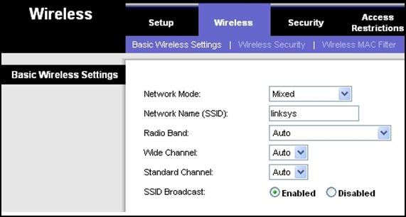Refer to the exhibit. Which two settings could be changed to improve security on the wireless network? (Choose two.)
  Correct  Response | Your  Response
   | network mode
   | SSID
   | radio band
   | wide channel
   | standard channel
   | SSID broadcast

This item references content from the following areas:
Introduction to Networks
- 11.5.2 Configuring the Integrated Router

49
  Fill in the blank using a number.
  The minimum Ethernet frame size is bytes. Anything smaller than that should be considered a "runt frame."
  Ethernet II and IEEE 802.3 standards define the minimum frame as 64 bytes and the maximum as 1518 bytes.

This item references content from the following areas:
Introduction to Networks
- 5.1.2 Ethernet Frame Attributes

50
  Fill in the blank.
  In dotted decimal notation, the IP address is the last host address for the network 172.25.0.64/26.
  The binary representation of the network address 172.25.0.64 is 10101100.00011001.00000000.01000000, where the last six zeros represent the host part of the address. The last address on that subnet would have the host part equal to 111111, and the last host address would end in 111110. This results in a binary representation of the last host of the IP address as 10101100.00011001.00000000.01111110, which translates in decimal to 172.25.0.126.

This item references content from the following areas:
Introduction to Networks
- 9.1.3 Subnetting an IPv4 Network

52
  Fill in the blank. Do not abbreviate. Use lower case.
  Which interface configuration mode command puts a Layer 3 switch interface into Layer 3 mode? ​
  The no switchport command applied at the interface configuration mode puts a Layer 3 switch interface in the Layer 3 mode.

This item references content from the following areas:
Introduction to Networks
- 5.3.3 Layer 3 Switching

53
  Question as presented:
  A logical topology diagram typically depicts the IP addressing scheme and groupings of devices and ports. A physical topology diagram shows how those devices are connected to each other and the network, focusing on the physical locations of intermediary devices, configured ports, and cabling.

This item references content from the following areas:
Introduction to Networks
- 1.2.1 Components of a Network

Your response:

55
  Question as presented:

This item references content from the following areas:
Introduction to Networks
- 11.2.1 Network Device Security Measures

Your response:

56
  Open the PT activity. Perform the tasks in the activity instructions and then answer the question.
  Which information is obtained from this command output?
  Correct  Response | Your  Response
   | 10.20.20.3, authoritative answer
   | 10.20.20.3, non-authoritative answer
   | 10.20.20.4, authoritative answer
   | 10.20.20.4, non-authoritative answer
  The nslookup command has to be used to obtain information about the FTP site. After issuing this command on the PC1 command prompt, a prompt ">" will be displayed. Then the user enters the name of the site to obtain its information which includes the address of the site (10.20.20.3) and the type of answer given by the DNS server. In this case, it was a non-authoritative answer.

This item references content from the following areas:
Introduction to Networks
- 10.2.2 Providing IP addressing Services

57
  Open the PT Activity. Perform the tasks in the activity instructions and then answer the question.
  What is the secret keyword that is displayed on the web page?
  Correct  Response | Your  Response
   | router
   | switch
   | frame
   | packet
   | cisco

This item references content from the following areas:
Introduction to Networks
- 6.4.2 Configure Interfaces

